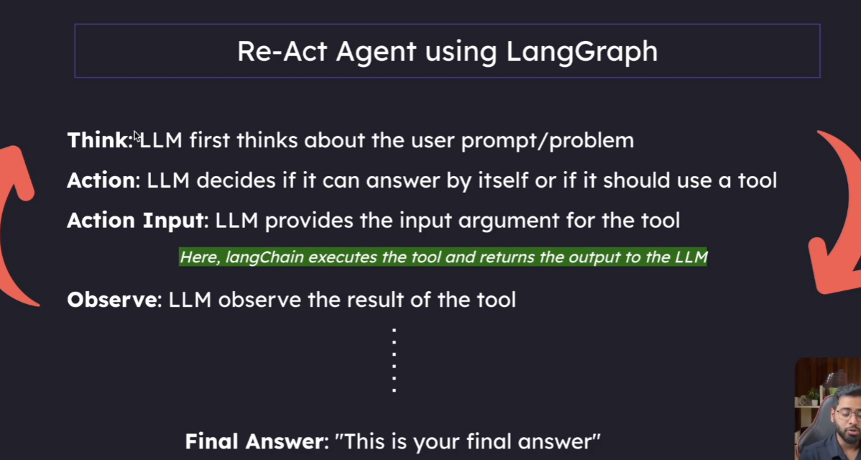
The one we studied in LangChain ReAct agent is not really in our control but when we use this LangGraph we have control. https://chatgpt.com/c/69f5bf60-cd9c-83e8-a92a-c62f97f41053
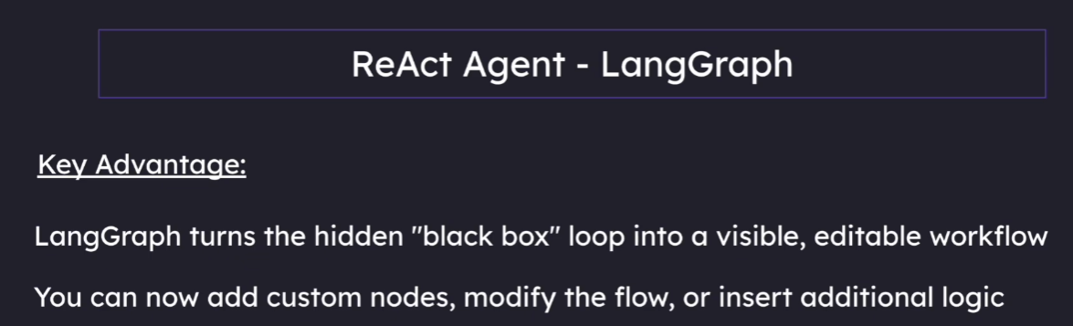
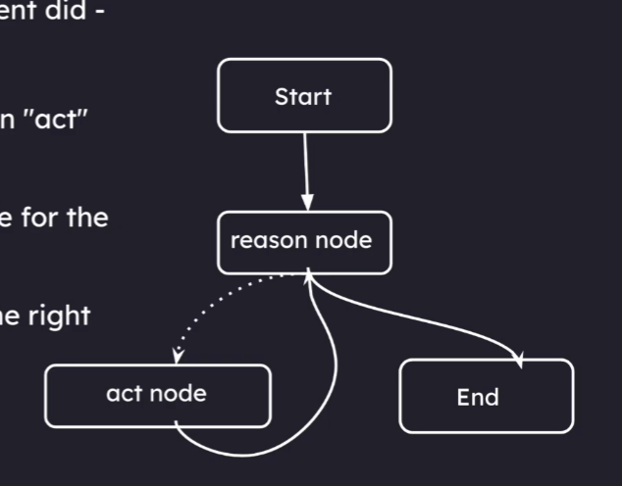
The agent has Reason node and the acting node

